6/30/2019

Kyer Potts

30003389

Scripting AT2.3

Conduct Test, Review Results and Demonstrate

Table of Contents

Testing 1

Test Case 1

Unit Test Results 2

Review 4

Test Summary 4

Test Improvements 4

Recommendation for Further Development 4

# Testing

## Test Case

|  |  |  |  |
| --- | --- | --- | --- |
| Case ID | Description | Expected Result | Outcome |
| 1. | GUI connects to chosen COM Port successfully | Connects to Arduino from selected COM port | Connection Successful |
| 2. | GUI display correct outside Temperature Information | Current temperature at sensor displayed in Textbox control | Current temperature displayed successfully and accurately |
| 3. | GUI displays correct inside Temperature Information | Current temperature at sensor displayed in Textbox control | Current temperature displayed successfully and accurately |
| 4. | GUI displays correct inside Humidity information | Current humidity at sensor displayed in Textbox control | Current humidity displayed successfully and accurately |
| 5. | Red LED toggle buttons toggles Red LED On/Off | Button turns LED on, press again to turn it off | Button toggles red LED on and off successfully |
| 6. | Mood light radio buttons toggle respective mood light colour On/Off | Radio buttons toggle their respective coloured LEDs | Respective coloured LED’s toggle on and off successfully |
| 7. | Blue light toggles On in low light | Blue light turns in low light situations | Blue LED turns on successfully |
| 8. | Blue light toggles Off in low light | Blue light turns in high light situations | Blue LED turns off successfully |
| 9. | Max Temp can be altered successfully | Max Temp setting can be changed by selecting desired temperature from dropdown box | Max Temp feature works successfully |
| 10. | Buzzer sounds when current inside Temperature readings exceed chosen Max Temp setting |  |  |

## Unit Test Results

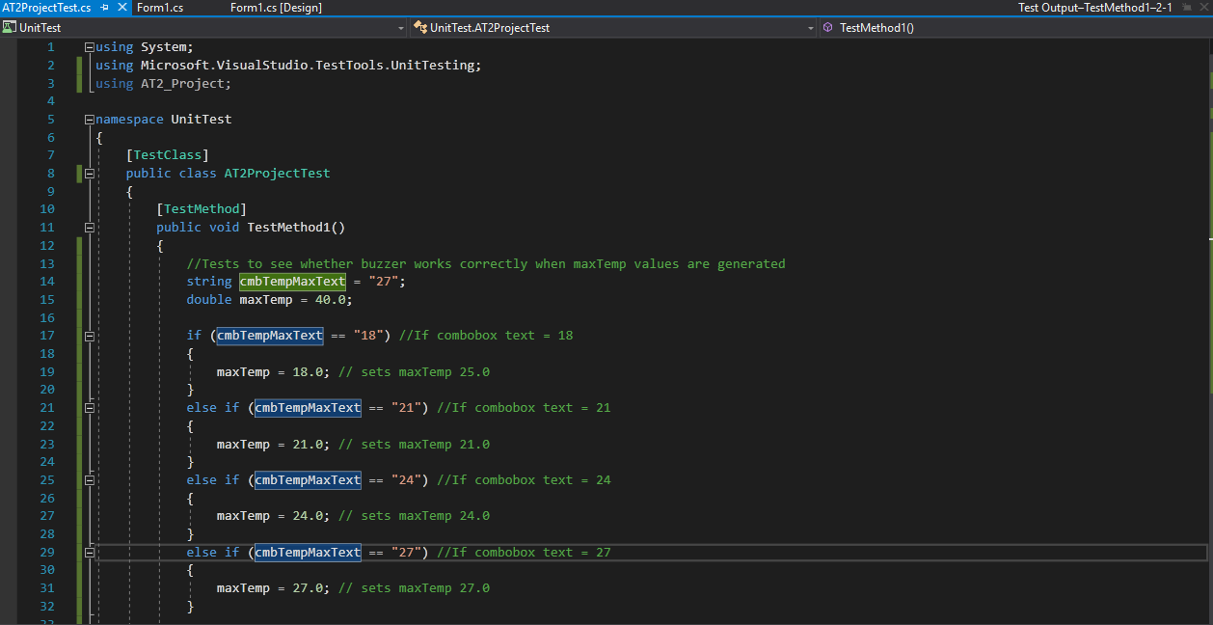

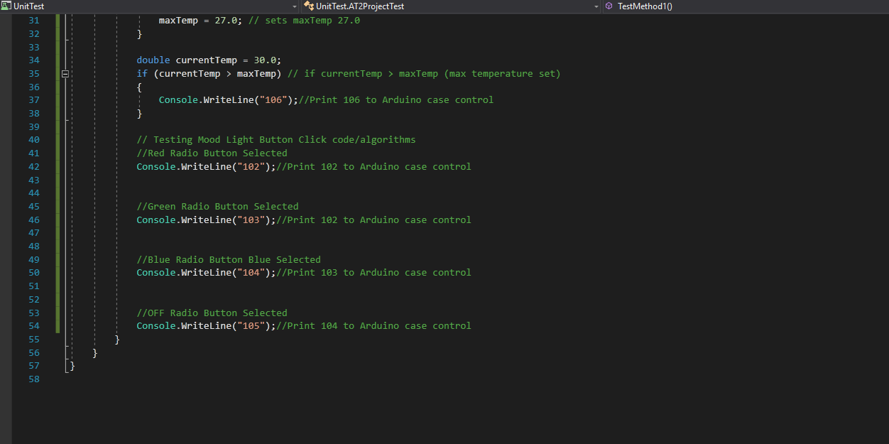

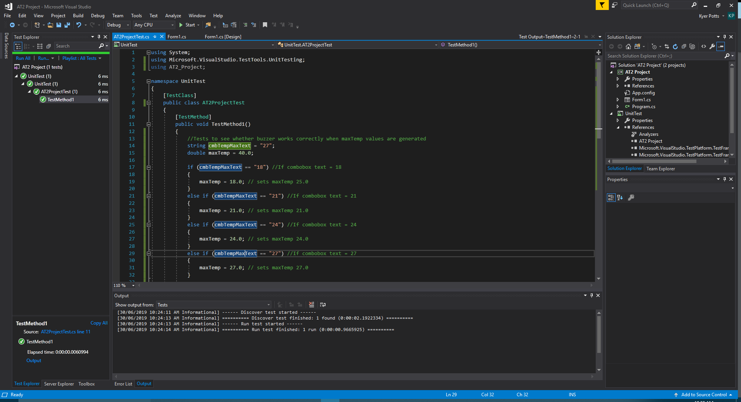

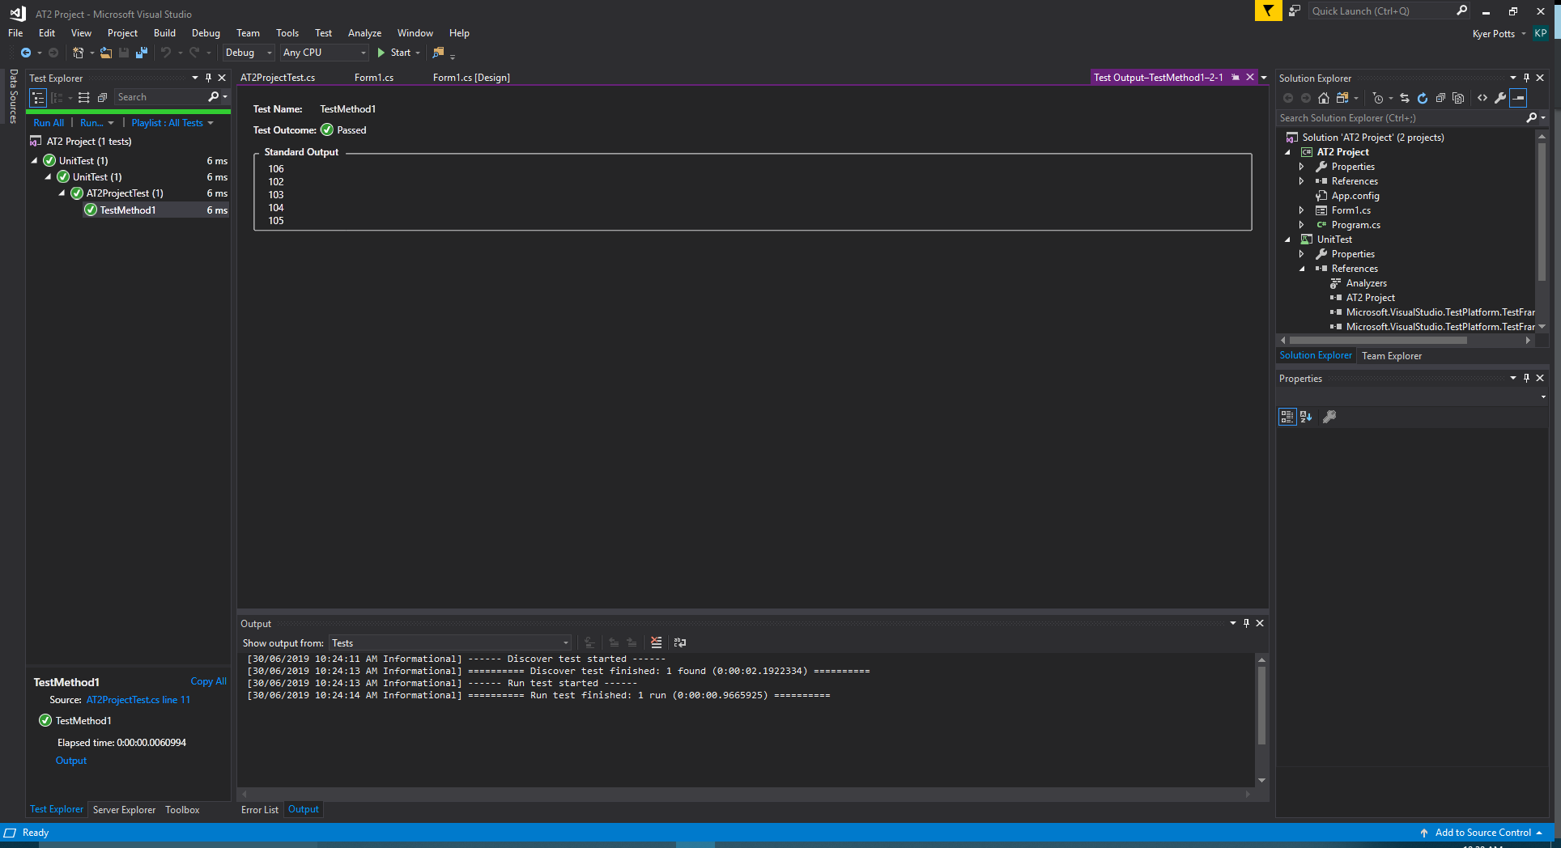

The unit tests conduct tests with write value outputs equivalent to their respective statements within the project build. All tests were completed successfully, and the correct write values were written to the console.

# Review

## Test Summary

The testing in these test procedures was designed to ensure that the project features and requirements all tested with correct output values for their intended practical uses. These output values all met the expected results and cleared the final build for implementation.

## Test Improvements

The tests conducted were by no means exhaustive and were only designed to test the implemented features of the project. Further tests to ensure that all user input values could be received with adequate error handling, and stress tests could help to refine the code to ensure that the program was running with maximum possible CPU and memory efficiency.

## Recommendation for Further Development

The project could be developed further by adding additional functionality to lighting features of the project. The Arduino device is capable of writing differing levels of light value to the shield which can alternate brightness. Toggle controls or a slider could be implemented into the GUI to control the brightness levels written to the device.